Social Media Data Analysis
Scenario
You are working as a Database Analyst for a new social media platform called ConnectHub. The company stores user data, posts, likes, friendships, and comments in a any database. Your task is to analyze and query the database to derive insights about user activity and relationships.
The challenge will test your ability to use subqueries, joins, and stored procedures in SQL.
Database Schema
- Users

Column Type Description
user_id INT (PK) Unique ID of the user username VARCHAR User’s profile name email VARCHAR User’s email address join_date DATE Date user joined
- Posts

Column Type Description
post_id INT (PK) Unique ID of the post user_id INT (FK) Author of the post content TEXT Post text/content post_date DATETIME Date and time of posting

- Likes

Column Type Description
like_id INT (PK) Unique like ID
Column Type Description
user_id INT (FK) User who liked post_id INT (FK) Post that was liked like_date DATETIME Date and time of like
- Comments

Column Type
Description
comment_id INT (PK)
Unique comment ID
post_id INT (FK)
Post commented on
user_id INT (FK)
Comment author
comment_text TEXT
Comment content
comment_date DATETIME Date and time of comment
- Friendships

Column Type Description
friendship_id INT (PK) Unique ID user_id1 INT (FK) User 1 user_id2 INT (FK) User 2
since_date DATE Date friendship started
Tasks
Task 1:
- Retrieve all posts along with the username of the author.
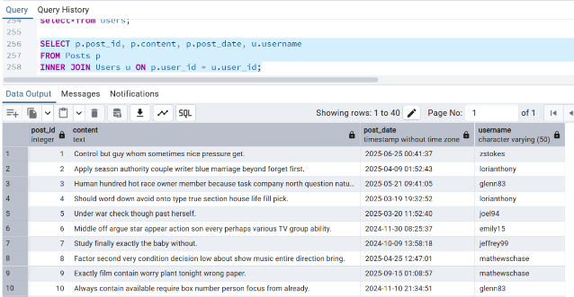
- Find all comments on each post along with the commenter’s username.
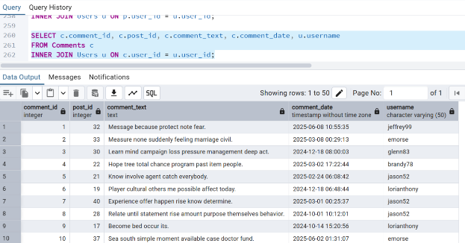

Task 2:
- Find the top 3 users with the most posts.
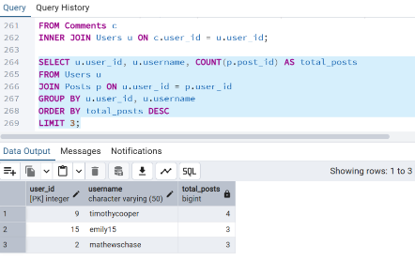

- Retrieve posts that have more likes than the average number of likes per post.
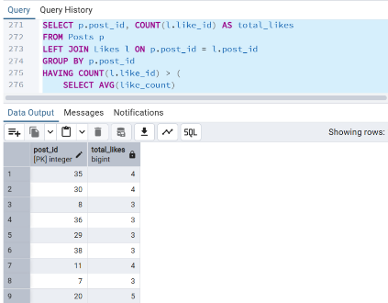

- Find users who have never posted anything but have liked posts.
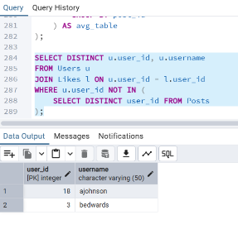
Task 3:
- Get a list of all friends of a specific user (say user_id = 3).
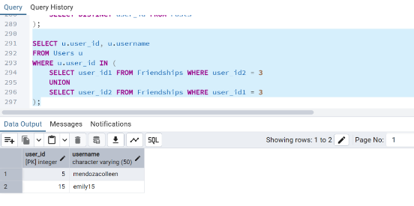

- Retrieve posts that were liked by friends of a given user (nested join scenario).
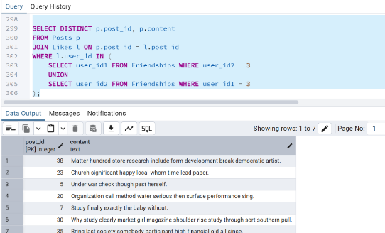

Task 4:
- Create a stored procedure GetUserActivity(userId) that returns:
- Total posts by the user
- Total likes given by the user
- Total likes received on the user’s posts
- Total comments made by the user
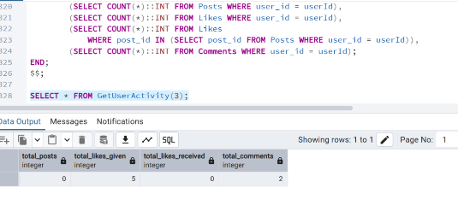

Task 5: Challenge Query
- Find the most influential user (the user whose posts have the highest total likes + comments).
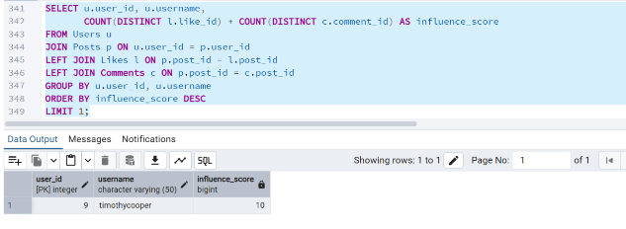
Expected Outcomes
- Demonstrate understanding of JOINs (INNER, LEFT, SELF JOIN), subqueries (scalar, correlated, nested), and stored procedures.
- They should be able to interpret real-world problems into SQL solutions.
- Can optimize queries using indexes and group by/having clauses.

